|  |
| --- |
| **NUCL 355 Experiment 4** |
| Flow Around Submerged Objects - Visualization  Professor S. T. Revankar |
|  |
| School of Nuclear Engineering  Purdue University  Report of the Experiment By:  Weston Cundiff, Stephen Cox, Kara Luitjohan, Patrick Burk, Dominic Ghering, Michael Stryker, Austin Curtis, Matt Metzger, et. Al. |
| **Written By Alex Hagen** |
| **2/15/2011** |
|  |

# Introduction and Theory

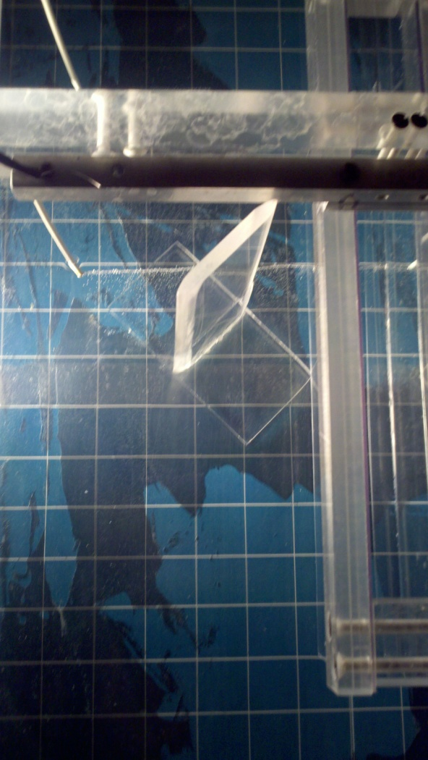In external flow, there are many phenomena that occur that may be counterintuitive or strange to the common conceptions of flow. One such phenomenon is that of Karman vortices. When a bluff body is placed in external flow, the combination of pressure and friction drag creates a pressure and velocity distribution that affect the flow in complicated ways. These ways always end up in a geometric spiral pattern, where the high velocity flow from around the outside of the bluff body curls back onto itself into the low pressure zone behind the bluff body. This spiral is considered a Karman vortex, and in faster flows the frequency of these phenomena can be used to measure the rate of flow moving past the bluff body.

Figure . Bluff body in an external flow

One of the physical reasons for Karman vortices is drag, which has two different types. The first type, pressure drag, is the most important to Karman vortices. When a body is placed inside of a flow, at the point of the body, the dynamic head is converted into pressure. The point of maximum pressure (and minimum velocity) is called the stagnation point. Across the front of any body in external flow will be a higher pressure because of this conversion of dynamic head to pressure. Conversely, directly behind the body will be a region of low pressure. This region of low pressure occurs because the flow cannot recombine fast enough after moving past the body to create the normal pressure of the system. This pressure drag and region of low pressure is so significant, it is used to create lift by airplane wings.

Friction drag, the other type of drag, has much less effect on bluff bodies. The roughness of a surface will create an opposition to flow past the body on which the surface resides. This opposition to flow is the drag that is created is the friction drag, which is at much smaller values than that of pressure drag in a flow. Friction drag helps pressure drag by contributing small shaping drag to create Karman vortices.

One geometry that can be used to illustrate both pressure and friction drag is that of a cylinder in external flow. The stagnation point is at the point of the cylinder where the surface is perpendicular to the flow, where the highest pressure drag occurs. The point where the surface of the cylinder is parallel to the flow is the point where there is absolutely no pressure drag, only friction drag. The illustration shown below helps illustrate how the flow will move past the cylinder. Pay special attention to the vortices that are created just past the cylinder on either sides. These are the Karman vortices being discussed.

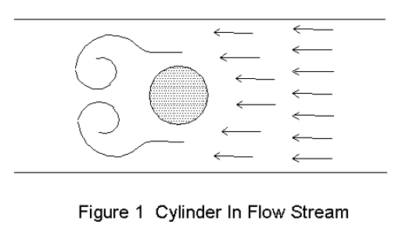

Figure .2 Cylinder in Flow Stream

Another feature of Karman vortices is their dependence on the velocity in the flow. The shape, size, and wake length of the flow all depend on the velocity of the flow, and thus the Reynold’s number of the flow. A faster flow will exert more pressure drag on the front of the body, and will take longer to recombine after the body. This will exhibit a longer wake length and a larger vortex diameter. It will also make the oscillation of the vortices occur at much lower periods. In Karman flow meters, the “vortex shedding rate” is used to calculate the speed of a flow, using the equation:

$$V=\frac{fD}{s}$$

Where V is the velocity, f is the shedding frequency, D is the diameter of the vortex, and s is a parameter defined by the Reynold’s number of the system. S is considered to be 0.21 for flows in which Re is greater than 100, so for most practical purposes.

# Analysis and Discussion of Data

For proper analysis of external flow around submerged bodies, the effects of increased flow velocity on the Karman vortices created must be analyzed. The Reynold’s Numbers for the flow were calculated as per the sample calculation in the appendices. In an attempt to correlate the flow to Karman vortices, these Reynold’s numbers were compared to calculated values for the Karman vortex frequency.

The chart below shows this relationship. There is not an obvious mathematical relationship that can be described from the chart. It is likely that the method of measuring the vortex diameter was vastly inaccurate (greater than 20% error), and because of the Vortex Frequency calculation’s dependence on this parameter, the data was skewed away from showing the real correlation.

Figure .1 Reynold's Number vs. Karman Vortex Frequency

In a further attempt to correlate the Reynold’s numbers to the Karman vortices, the actual physical characteristics were compared to the Reynold’s number. The chart below shows the vortex diameter compared with the Reynold’s number. The random scatter of this chart, which resembles the scatter of the above chart, further reinforces that the inaccuracies came in the measurement of the vortex diameter.

Figure .2 Reynold's Number vs. Vortex Diameter

When the wake lengths were plotted against the Reynold’s number, the correlation between the vortexes and the Reynold’s Number started to become obvious. As the chart below shows, there is obviously a positive correlation between these two parameters. The wide spread of Flow 1 suggests inaccuracies in measurement during Flow 1, which may have also affected the correlations in the previous analyses.

Figure .3 Reynold's Number vs. Wake Length

As Karman vortices can be only be truly described in a semi-quantitative way, the most appropriate way to present information about the vortices is through sketching and diagrams of the vortices themselves. This can highlight the shape, size and other features of these vortices. This can be used to analyze the proportions of friction drag to pressure drag, and the vortex shedding in the system. The following pages are general block diagrams of Karman Vortices. Block diagrams were used because the analysis of the photographs did not present good evidence to present the data (the bubbles were not visible in the photographs taken). The plate parallel to flow case was also not present, because it did not cause vortices.

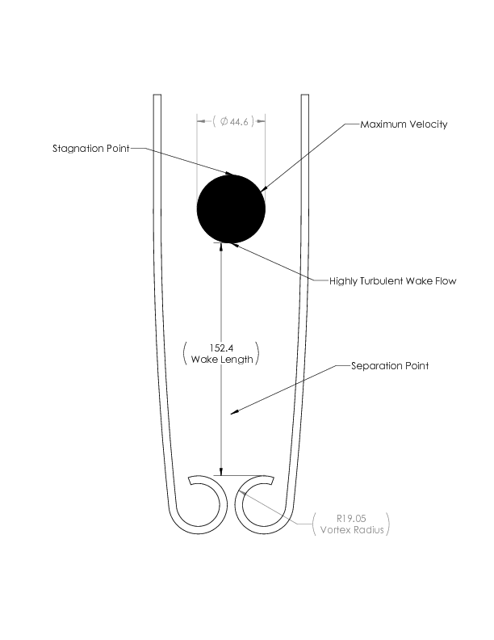

Figure .4 Cylinder Karman Vortex Diagram

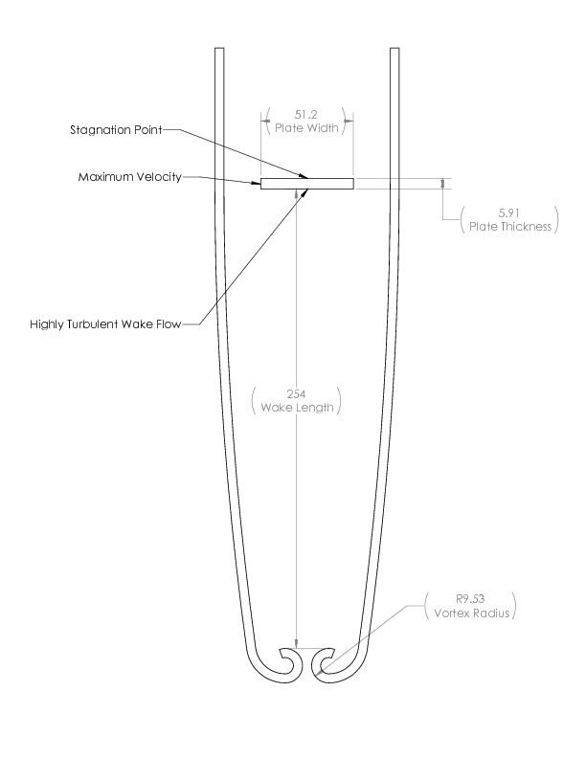

Figure .5 Perpendicular Plate Karman Vortex Diagram

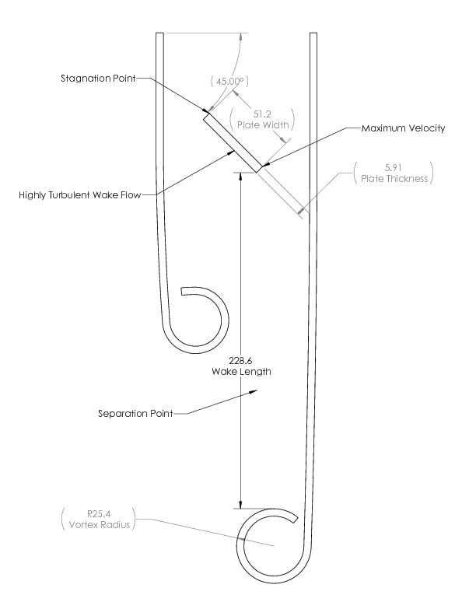

Figure .6 45 deg Plate Karman Vortex Diagram

# Conclusions

The conclusions for the experiment fall into several categories. The first category deals with the shape of Karman vortices and what types of drag can create them. The second category explains the correlation between the speed of a flow and the shape and size of the vortex properties of this flow. The final category is more of a recommendation or improvement in the experiment that would help the operation of this experiment in the future.

As shown in the semi-quantitative drawings of the Karman vortices that were noted during this experiment, there is a very systematic nature to the geometry of these vortices. The cylinder showed a classic shape, and exhibited defined vortices of diameter 38.1 mm. The wake length was the smallest for the cylinder, because it had less pressure drag than the other cases. The stagnation point is clearly defined in this case.

For the perpendicular case, the situation looked very similar, but included much different underlying theory. Because of the shape, the stagnation point is not defined, but is actually an entire line across the front of the plate. The wake length was the longest of all, at 254 mm, because pressure drag dominates this kind of obstruction. The vortexes were small, only 19.05 mm because of the length of separation in this type of system.

The most complicated system is the non-symmetric 45 deg system. The wake length was very similar to the parallel plate, at 228.6 mm, but the vortex size was more than double that of the perpendicular plate. This is because of the non-symmetry, which causes a more turbulent region behind the plate. The flow coming around one side of the plate is able to recombine before the other, and thus has a large low pressure region to move into, creating a large vortex.

These shapes are all governed by the speed of the system, and thus the Reynold’s numbers involved with the flow found in the system. Two different flow speeds were analyzed in this experiment. In Flow 1, the Reynold’s numbers ranged from 102.48 all the way up to 887.23; in Flow 2 the range was from 67.93 to 588.11. These wide ranges of Reynold’s numbers helped to analyze the system through a variety of flow situations.

During analysis of these flow situations, it was shown that there is a positive correlation between flow velocity (Reynold’s number) and the wake length. It was also shown that there is a very weak correlation between the Reynold’s number and Karman frequency or Vortex diameter. This correlation is still positive, but does not exhibit the behavior of two parameters that are related. It is believe that the system for measuring the vortex diameter was wildly inaccurate and thus propagated error into the frequency of vortex shedding.

This inaccuracy leads to the third conclusion of the report. It is important to be able to visualize these vortices to be able to measure their size and sketch their shape. The hydrolysis source that was used for bubbles created very small bubbles on the day that the experiment was attempted. The tiny bubbles were no longer visible after several inches. Because of the loss of visibility of the bubbles, it was almost impossible to see where the vortexes were forming. Ink was attempted, but it is also an inaccurate method because of the hysteresis of the ink in the water. It is a recommendation that a better way to visualize the flow be developed before attempting the experiment again.

# Works Cited

Munson, Y. O. (2009). *Fundamentals of Fluid Mechanics.* Hoboken, NJ: Wiley and Sons, Inc.

Revankar, S. (2011). *Experiment #4: Flow Around Submerged Objects – Visualization.* West Lafayette, IN: Purdue University School of Nuclear Engineering.

# Appendices

## Original Data

### Velocities

|  |
| --- |
| Flow 1 (s) |
| 8.47 |
| 8.77 |
| 8.93 |
| 8.88 |
| 8.82 |

Table .1 Flow 1 Velocity Data

|  |
| --- |
| Flow 2 (s) |
| 12.51 |
| 13.61 |
| 12.29 |
| 14.81 |

Table .2 Flow 2 Velocity Data

### Karman Vortices

|  |  |  |  |
| --- | --- | --- | --- |
| Flow 1 | Blocking Object | Measured Parameter | |
| Cylinder | | Wake Length (in) | 6 |
| Vortex Diameter (in) | 1.5 |
| Plate Perpendicular to Flow | | Wake Length (in) | 10 |
| Vortex Diameter (in) | 0.75 |
| Plate 45 degrees to Flow | | Wake Length (in) | 9 |
| Vortex Diameter (in) | 2 |
| Plate Parallel to Flow | | Wake Length (in) | 7 |
| Vortex Diameter (in) | 0.5 |

Table .3 Flow 1 Vortex Data

|  |  |  |  |
| --- | --- | --- | --- |
| Flow 2 | Blocking Object | Measured Parameter | |
| Cylinder | | Wake Length (in) | 5.5 |
| Vortex Diameter (in) | 0.5 |
| Plate Perpendicular to Flow | | Wake Length (in) | 7 |
| Vortex Diameter (in) | 1.5 |
| Plate 45 degrees to Flow | | Wake Length (in) | 5 |
| Vortex Diameter (in) | 0.5 |
| Plate Parallel to Flow | | Wake Length (in) | None Visible |
| Vortex Diameter (in) | None Visible |

Table .4 Flow 2 Vortex Data

### Measurements

|  |
| --- |
| Diameter (inch) |
| 1.755 |
| 1.756 |
| 1.756 |

Table .5 Cylinder Diameter

|  |  |
| --- | --- |
| Thickness (inch) | Width (inch) |
| 0.236 | 2.011 |
| 0.231 | 2.028 |
| 0.231 | 2.004 |

Table .6 Short Plate Dimensions

|  |  |
| --- | --- |
| Thickness (inch) | Width (inch) |
| 0.244 | 1.755 |
| 0.245 | 1.729 |
| 0.245 | 1.744 |
|  | 1.743 |

Table .7 Tall Plate Dimensions

## Reduced Data

|  |  |  |  |  |  |  |  |  |
| --- | --- | --- | --- | --- | --- | --- | --- | --- |
| Time (s) | Velocity (m/s) | Re_Cyl | Re_perps | Re_perpt | Re_45s | Re_45t | Re_pars | Re_part |
| 8.47 | 0.018 | 800.77 | 918.75 | 794.88 | 649.66 | 562.07 | 106.12 | 111.59 |
| 8.77 | 0.017 | 773.38 | 887.32 | 767.69 | 627.43 | 542.84 | 102.49 | 773.38 |
| 8.93 | 0.017 | 759.52 | 871.43 | 753.94 | 616.19 | 533.11 | 100.65 | 759.52 |
| 8.88 | 0.017 | 763.80 | 876.33 | 758.18 | 619.66 | 536.12 | 101.22 | 763.80 |
| 8.82 | 0.017 | 769.00 | 882.29 | 763.34 | 623.88 | 539.76 | 101.91 | 769.00 |
| Average | 0.017 | 773.30 | 887.23 | 767.61 | 627.36 | 542.78 | 102.48 | 773.30 |
| Vortex Diameter (m) | | 0.0381 | 0.01905 | 0.01905 | 0.0508 | 0.0508 | 0.0127 | 0.0127 |
| Wake Length (m) | | 0.1524 | 0.254 | 0.254 | 0.2286 | 0.2286 | 0.1778 | 0.1778 |
| Karman Frequency (1/s) | | 0.09577 | 0.1915 | 0.1915 | 0.0718 | 0.0718 | 0.2873 | 0.2873 |

Table .8 Vortex Frequency Calculation Data (Flow 1)

|  |  |  |  |  |  |  |  |  |
| --- | --- | --- | --- | --- | --- | --- | --- | --- |
| Time (s) | Velocity (m/s) | Re_Cyl | Re_perps | Re_perpt | Re_45s | Re_45t | Re_pars | Re_part |
| 12.51 | 0.012 | 542.17 | 622.05 | 538.18 | 439.86 | 380.55 | 71.85 | 75.56 |
| 13.61 | 0.011 | 498.35 | 571.77 | 494.68 | 404.31 | 349.79 | 66.04 | 69.45 |
| 12.29 | 0.012 | 551.88 | 633.18 | 547.82 | 447.73 | 387.36 | 73.14 | 76.91 |
| 14.81 | 0.010 | 457.97 | 525.44 | 454.60 | 371.55 | 321.45 | 60.69 | 63.82 |
| Average | 0.012 | 512.59 | 588.11 | 508.82 | 415.86 | 359.79 | 67.93 | 71.43 |
| Vortex Diameter (m) | | 0.0127 | 0.0381 | 0.0381 | 0.0127 | 0.0127 | -- | -- |
| Wake Length (m) | | 0.1397 | 0.1778 | 0.1778 | 0.127 | 0.127 | -- | -- |
| Karman Frequency (1/s) | | 0.1904 | 0.0635 | 0.0635 | 0.1904 | 0.1904 | -- | -- |

Table . Vortex Frequency Calculation Data (Flow 2)

## Sample Calculations

### Velocity

Measurements were taken for flow over 6 inches, giving us a time (t).

$$V=\frac{6 inches →m}{t}=\frac{.1524 m}{8.47 s}=0.018\frac{m}{s}$$

These values were then averaged to find the velocity of each flow.

### Blocking Diameter (d) for 45o Plate

### Reynold’s Number

In this case (external flow, d is the diameter or across stream length of the item blocking flow)

$$Re=\frac{ρVd}{μ}=\frac{\left(1000\frac{kg}{m^{3}}\right)\left(0.018\frac{m}{s}\right)\left(0.0446 m\right)}{1.002*{10}^{-3}}=800.77$$

### Vortex Frequency

$$V=\frac{fD}{s}$$

$$s=0.21 for Re>100$$

$$D=0.0381 m$$

$$V=.017\frac{m}{s}$$

$$f=\frac{Vs}{D}=\frac{\left(0.017\frac{m}{s}\right)\left(0.21\right)}{0.0381 m}=0.09577 s^{-1}$$